Research Project Concept Approval Form
- PURPOSE
  - To define research project concepts on Wyndhurst Farm for communication, collaboration and approval with the Bristol Veterinary School (BVS) John Oldacre Centre (JOC).
- RESPONSIBILITIES
  - The Principal Investigator
    - Is responsible for communicating the study plan (section 3.6) to the JOC, via completion, submission and maintenance of this form. Please rename this document using the following format: “[short study title] ([insert name]).docx”
    - If you are not already a member of the JOC then you will be required to identify a collaborator from within the JOC to ensure Research Excellence Framework (REF)-return on publications.
    - If necessary, attend a JOC Research Concept Approval meeting to discuss project details, such as animal welfare concerns or conflicts with other teaching or research activities. The panel will consist of the JOC research project manager, farm management, veterinary services, teaching staff and other relevant JOC representative(s). This form must reflect the changes proposed the approval panel to meet the logistical limitations of the Farm.
    - Adhere to the grp-Wyndhurst Farm calendar timetable or suggest amendments to the JOC research project manager for rescheduling.
    - Complete other BVS research requirements, such as the ethical review form(s):
      - Application for Ethical Approval of studies involving Animals (UIN) for non-clinical studies where animals are observed or have non-invasive procedures.
      - Application for Ethical Approval of a Veterinary Investigation (VIN) for all studies on clinical caseload, including retrospective studies, those using surplus blood and observational studies. Please see Veterinary Clinical Research Guidance document for further information.
      - Home Office License – required for any procedure which uses any invasive procedure equal or more than inserting a needle. Contact asu-holt@bristol.ac.uk with enquiries.
- PROCEDURE
  - Flow chart
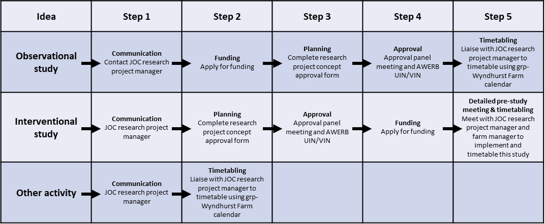
  - Communicate your proposed activity: Notify the JOC research project manager of your proposed activity (e.g. site visit, data collection, data share, observational or interventional study) with sufficient detail of the proposed activity (e.g. date, time, people, duration, location, nature of activity).
  - Planning: Where appropriate, submit a completed study plan (Section 3.6) to the JOC research project manager to initiate the research project concept approval process, detailed below (3.4 and 3.5)
  - Approval:
    - Interventional studies, defined as studies that intervene with normal farm procedure or animal handling, may require a JOC approval panel meeting to discuss relevant project details.
    - Observational studies, defined as a study that does not intervene with normal farm procedure, can be fast-tracked by approval at the monthly JOC meeting or by email thread discussion.
    - Other activities, such as site visits and data sharing, can be approved by the JOC research project manager providing 1) there are no conflicts, 2) you agree to the farm data confidentiality agreement (section 4) and 3) a collaborator from the JOC has been identified.
Please note: research project concept (JOC) and ethical (AWERB) approval should be completed before a funding application is submitted.
  - Timetabling: Studies will be timetabled by the JOC research project manager using the grp-Wyndhurst Farm calendar and decisions will be based on the availability of resources (farm management, facilities, livestock requirements, animal usage, teaching requirements, etc.). A contingency buffer will be added between incompatible projects to allow for unforeseen circumstances or delays. Please note: space and time conflicts between projects will be reviewed by the JOCE board on a case-by-case basis with a focus towards prioritising external funding and compatibility with other projects.
  - Detailed study plan
Please complete the following form to define your observational (inc. data science) or interventional study:
Descriptive Title
Proposed timeline | Start date? E.g. April 2023  End date? E.g Oct 2023  Are there other deadlines to be considered? E.g. contract end dates, review periods
Study type | Interventional? (altered farm procedure, animal handling or data collection) Yes: ☐ No: ☐  Observational? (normal farm procedure and animal handling) Yes: ☐ No: ☐
Study requirements  (Interventional only) | Will animals be moved/tested/used? Yes: ☐ No/just observed: ☐  If yes, include details (number, age, gender, milking status, healthy/sick, activity, etc.):  Will samples be taken? Yes: ☐ No: ☐  If yes, include details (type, sample size, collection duration and interval, etc.):  Will animal handling change? (Diet, housing, companionship, disease treatment)  Yes: ☐ No: ☐  If Yes, please provide details (inc. links to protocols):
Study requirements  Interventional or observational) | Do you need to purchase, install or use existing equipment? Yes: ☐ No: ☐  If yes, please list and describe: e.g. hurdles added to calf high health units, weigh scales in crush during TB testing, cameras in calf hutches, etc.  Do you require additional space on farm? Yes: ☐ No: ☐  If yes, please describe: e.g. calf high health units, behaviour pen, etc.  Do require farm data? Yes: ☐ No: ☐  If yes, describe the data requirements:
Brief Description of Study
(200 word limit)

Name of JOC or BVS collaborator | Name:
Sponsor | Name:  Address:
Other sites involved? | Address:
Conflicts | Are you aware of any potential conflicts with planned or ongoing projects? Yes: ☐ No: ☐  If yes, please describe:
Signatures | Signed: e.g. principle investigator  Date:  Signed: e.g. collaborator or other relevant researcher  Date:

  - Document distribution
    - JOC research project manager will circulate this document with the farm manager and JOC executive board.
- Agreements
To retrieve farm data you must agree to the confidentiality terms and conditions of farm data | ☐ I agree not to share farm data with a third party and will store data on an encrypted laptop or on a secure, password protected, University of Bristol system and discuss data privacy or anonymity of the farm location with the JOC before publication.
To create farm data you must agree to the university General Data Protection Regulations (GDPR) | ☐ I agree not to share personal information, including images, by 1) storing data on an encrypted laptop or on a secure, password protected, University of Bristol system, 2) removing or blurring personal data for publication and 3) not storing data longer than required for this project.
I agree to appropriately acknowledge or credit relevant JOC or farm staff input on this study | ☐ I agree to acknowledge or credit JOC or farm staff input where appropriate
Signature | Signed:  Date:

- Internal use only
Assistant Research Project Manager Actions | Action 1:  Action 2:  Action 3:  Actions completed? ☐
Access granted by JOCE approval panel | Yes: ☐ No: ☐  Signed:  Date:

